Parity Distribution — Sri Lanka Birth Registration

Figure 1: Birth Order Distribution
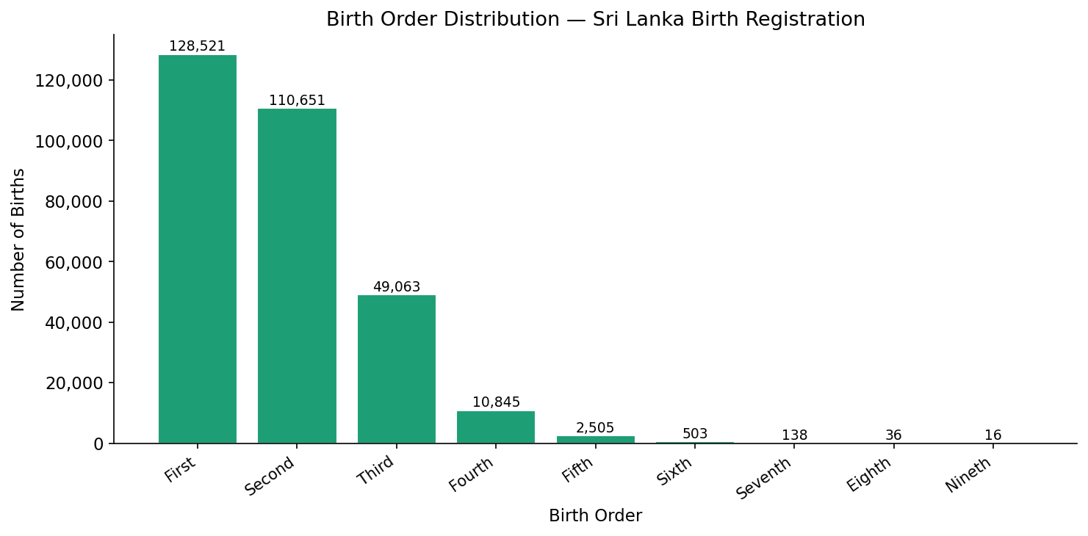

Table 1: Frequency Distribution of Birth Order
Birth Order | Parity | Frequency | Percentage % | Cumulative %
First | 1 | 128,521 | 42.52% | 42.52%
Second | 2 | 110,651 | 36.61% | 79.12%
Third | 3 | 49,063 | 16.23% | 95.35%
Fourth | 4 | 10,845 | 3.59% | 98.94%
Fifth | 5 | 2,505 | 0.83% | 99.77%
Sixth | 6 | 503 | 0.17% | 99.94%
Seventh | 7 | 138 | 0.05% | 99.98%
Eighth | 8 | 36 | 0.01% | 99.99%
Nineth | 9 | 16 | 0.01% | 100.00%
Total |  | 302,278 | 100.00% | 100.00%

Note: Parity refers to the number of live births a mother has had.

